
Initial Screening Report
Supplier ID: N/A
COCA COLA INDIA PRIVATE LIMITED
[COCA COLA india privateLIMITED]

20th May 2026

Contents

1. Company Profile 3
2. Executive Rating Summary 3
3. Detailed Findings 3
A. Entity Existence 3
B. Legal History and Open Cases 3
C. Financial Indicators 3
D. Adverse Media 3
4. Annexures 4
5. Data Sources 4

Company Profile

Uploaded Name | COCA COLA india privateLIMITED | Supplier ID | N/A
Name | COCA COLA INDIA PRIVATE LIMITED | Location | Mulshi, Maharashtra
Address | Plot Nos. 1109- 1110 Village Pirangut,Taluka -Mulshi,Pirangut, Mulshi, Pune, Maharashtra - 412115 | Website | https://www.coca-cola.com
E-Filing Status | Active | Classification | Private Limited Foreign Company Incorporated in India
Incorporation Date | 20/02/1992 | National Identifier | U15549PN1992FTC065522
Corporate Group | Shareholders: 1  Subsidiaries: 1 | Alias | BRITCO FOODS COMPANY LIMITED  BRITCO FOODS COMPANY PRIVATE LIMITED
Revenue | 50425569000 | Employee | N/A

OVERALL RISK RATING | High

Executive Rating Summary

The below ratings are assigned:
Risk Areas | Risk Rating
Entity Existence | Medium
Legal | High
Financial | Medium
Adverse Media | High
Cyber | Low

Detailed Findings

Entity Existence
Medium
This section shall list B2B existence, domain validation, and address validation for the entity.

Name & Relation | Google Address Validation | Rating | Medium
Findings
Factor | Value
Address | Plot Nos. 1109- 1110 Village Pirangut,Taluka -Mulshi,Pirangut, Mulshi, Pune, Maharashtra - 412115
Zone | Mixed
Reason | The area features various residential options along with numerous commercial establishments such as banks, hospitals, and shops.

Source: EY Network Alliance Databases

Name & Relation | Domain Validation | Rating | Low
Findings
Factor | Value
Domain Name | coca-cola.com
Creation Date | 14-10-1994
Expiration Date | 13-10-2026
Updated Date | 11-09-2025
Registrant Org | the coca-cola company
Registrant Country | us
Registrar | markmonitor, inc.
Registrar Url | http://www.markmonitor.com
Emails | abusecomplaints@markmonitor.com, whoisrequest@markmonitor.com
Dnssec | unsigned
Vendor Onboarding Date (Client Database)

Source: EY Network Alliance Databases

Address Validation
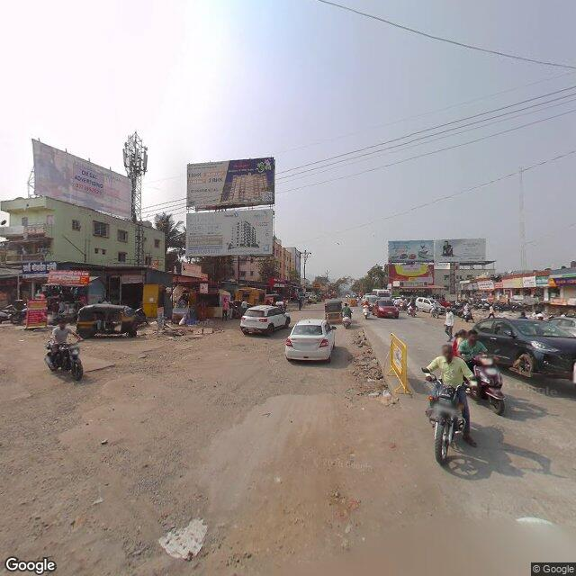 | 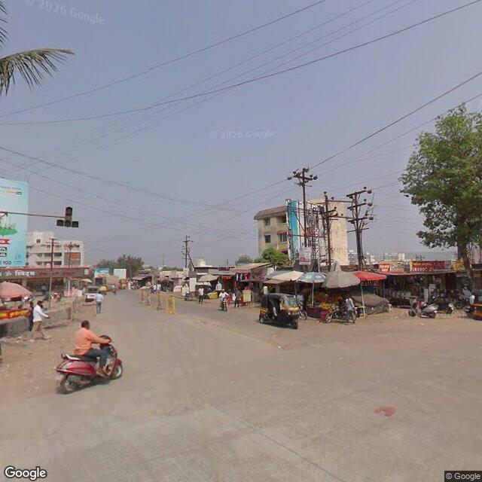 | 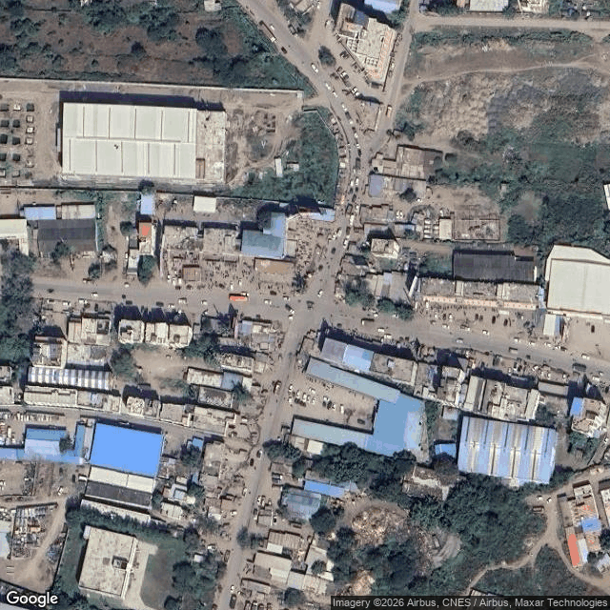

Legal History and Open Cases
High
This section shall list pending legal cases and open charges against the entity.

Name & Relation | Legal History | Rating | High
Findings
Following are Legal History
1. Date: 14.05.26 | Severity: medium | Status: Pending
Case No. CS /611/2022 was filed before the Civil Judge Senior Division, Mansa under the category of Civil Cases. This matter pertains to Cases Filed Against This Corporate, where M/S SINGLA BAVERAGES, SHWETA SINGLA has initiated proceedings against COCA COLA INDIA PRIVATE LIMITED.
2. Date: 08.05.26 | Severity: medium | Status: Pending
Case No. RCS /66/2025 was filed before the TALUKA COURT, KHEDA under the category of Civil Cases. This matter pertains to Cases Filed Against This Corporate, where IQBALUNISA D.O. AHMEDMIYA NANUMIYA SAIYAD AND W.O.MAJARALI SAIYAD has initiated proceedings against COCA COLA INDIA PRIVATE LIMITED.
3. Date: 02.03.20 | Severity: medium | Status: Pending
Case No. ITXAL/497/2020 was filed before the High Court of Bombay under the category of Taxation Matters. This matter pertains to Cases Filed Against This Corporate, where THE PR. COMMISSIONER OF INCOME TAX-1 has initiated proceedings against COCA COLA INDIA PVT. LTD..
4. Date: 02.03.20 | Severity: medium | Status: Pending
Case No. ITXAL/498/2020 was filed before the High Court of Bombay under the category of Taxation Matters. This matter pertains to Cases Filed Against This Corporate, where THE PR. COMMISSIONER OF INCOEM TAX-1 has initiated proceedings against COCA COLA INDIA PVT. LTD..
5. Date: 02.03.20 | Severity: medium | Status: Pending
Case No. ITXAL/480/2020 was filed before the High Court of Bombay under the category of Taxation Matters. This matter pertains to Cases Filed Against This Corporate, where THE PR.COMMISSIONER OF INCOME TAX-1 has initiated proceedings against COCA COLA INDIA PVT LTD.
6. Date: 02.03.20 | Severity: medium | Status: Pending
Case No. ITXAL/499/2020 was filed before the High Court of Bombay under the category of Taxation Matters. This matter pertains to Cases Filed Against This Corporate, where PR. COMMISSIONER OF INCOME TAX-1 has initiated proceedings against COCA COLA INDIA PVT. LTD..
7. Date: 02.03.20 | Severity: medium | Status: Pending
Case No. ITXAL/489/2020 was filed before the High Court of Bombay under the category of Taxation Matters. This matter pertains to Cases Filed Against This Corporate, where THE PR.COMMISSIONER OF INCOME TAX - 1 has initiated proceedings against COCA COLA INDIA PVT.LTD..
8. Date: 18.02.20 | Severity: medium | Status: Pending
Case No. ITXAL/404/2020 was filed before the High Court of Bombay under the category of Taxation Matters. This matter pertains to Cases Filed By This Corporate, where COCA COLA INDIA PVT LTD has initiated proceedings against THE DEPUTY COMMISSIONER OF INCOME TAX CIRCLE 1(1),PUNE.
9. Date: 18.02.20 | Severity: medium | Status: Pending
Case No. ITXAL/409/2020 was filed before the High Court of Bombay under the category of Taxation Matters. This matter pertains to Cases Filed By This Corporate, where COCA-COLA INDIA PRIVATE LIMITED (FORMERLY BRITCO FOODS LIMITED) has initiated proceedings against THE DEPUTY COMMISSIONER OF INCOME TAX, CIRCLE 1 (1), PUNE.
10. Date: 18.02.20 | Severity: medium | Status: Pending
Case No. ITXAL/403/2020 was filed before the High Court of Bombay under the category of Taxation Matters. This matter pertains to Cases Filed By This Corporate, where COCA-COLA INDIA PRIVATE LIMITED has initiated proceedings against THE DEPUTY COMMISSIONERE OF INCOME TAX, CIRCLE 1(1), PUNE.

Source: EY Network Alliance Databases

Financial Indicators
Medium
This section shall list balance sheet, profit and loss, profitability analysis, liquidity analysis, financial ratios, GST registration analysis, MSME registration validation, and related party transactions of the entity.

Name & Relation | Finance - MSME Registration Status | Rating | Medium
Findings
Factor | Value
MSME Status (Verified) | Unknown
MSME Status (Client Database) | Not Provided
Reason | MSME status unavailable or could not be confidently matched

Source: EY Network Alliance Databases

Name & Relation | Finance - Balance Sheet | Rating | INFO
Findings
Factor | 2025 | 2024 | 2023
Total Current Assets (₹ in Lakhs) | 204408.85 | 175737.98 | 282068.59
Total Other Non Current Assets (₹ in Lakhs) | 69724.08 | 69467.88 | 62706.87
Net Fixed Assets (₹ in Lakhs) | 58038.14 | 50565.58 | 34288.11
Total Current Liabilities (₹ in Lakhs) | 180711.42 | 170106.92 | 185419.38
Total Non Current Liabilities (₹ in Lakhs) | 13991.73 | 13873.01 | 6971.24
Total Equity (₹ in Lakhs) | 143293.38 | 113601.08 | 187964.82

Source: EY Network Alliance Databases

Name & Relation | Finance - Profit And Loss | Rating | INFO
Findings
Factor | 2025 | 2024 | 2023
Net Revenue (₹ in Lakhs) | 504255.69 | 471338.36 | 452131.88
Profit After Tax (₹ in Lakhs) | 61536.54 | 42017.26 | 72243.06

Source: EY Network Alliance Databases

Name & Relation | Finance - GST Registration Analysis | Rating | Low
Findings
Date Of Registration | State Of Registration | Gst In | Filing Timeliness
28.11.18 | Andhra Pradesh | 37AAACB8573G2ZH | Filed on Time
06.03.25 | Haryana | 06AAACB8573G3ZL | Filed on Time
01.07.17 | Haryana | 06AAACB8573G1ZN | Filed on Time
12.04.19 | Haryana | 06AAACB8573G2ZM | Filed on Time
01.07.17 | Karnataka | 29AAACB8573G1ZF | Filed on Time
01.07.17 | Madhya Pradesh | 23AAACB8573G1ZR | Filed on Time
01.07.17 | Maharashtra | 27AAACB8573G1ZJ | Filed on Time
14.03.18 | Maharashtra | 27AAACB8573G2ZI | Filed on Time
12.06.18 | Uttar Pradesh | 09AAACB8573G1ZH | Filed on Time

Source: EY Network Alliance Databases

Name & Relation | Finance - Related Party Transaction | Rating | INFO
Findings
Name | Relationship | Type Of Transaction | Amount (₹ In Lakhs)
HINDUSTAN COCA-COLA BEVERAGES PRIVATE LIMITED | Fellow Subsidiary | Revenue | 245852.11
The Coca-Cola Company, USA | Holding Company | Expense | 88604.87
HINDUSTAN COCA-COLA BEVERAGES PRIVATE LIMITED | Fellow Subsidiary | Expense | 38557.75
Coca-Cola South Asia (India) Holdings Limited, Hong Kong | Holding Company | Expense | 35945.5
European Refreshments Unlimited Company, Ireland | Fellow Subsidiary | Expense | 22515.65
The Coca-Cola Export Corporation, USA | Fellow Subsidiary | Revenue | 9650.04
INTERNATIONAL REFRESHMENTS (INDIA) PRIVATE LIMITED | Fellow Subsidiary | Expense | 7215.04
Coca-Cola India Inc., USA | Fellow Subsidiary | Expense | 2628.01
The Coca-Cola Company, USA | Holding Company | Revenue | 1917.9
COCA-COLA INDIA FOUNDATION | Subsidiary | Expense | 1370.31

Source: EY Network Alliance Databases

Name & Relation | Finance - MSME Payment Analysis | Rating | INFO
Findings
Period | Amount (₹ In Lakhs)
October 2022 to March 2023 | 2476.29
April 2023 to September 2023 | 4660.07
October 2023 to March 2024 | 2548.12
April 2024 to September 2024 | 12.7
April 2025 to September 2025 | 12.6

Source: EY Network Alliance Databases

Name & Relation | Finance - Profitability Analysis | Rating | Medium
Findings
Factor | 2025 | 2024 | 2023
Profit Margin Ratio (%) | 12.2 | 8.91 | 15.98
EBITDA Margin (%) | 18.78 | 14.41 | 23.47
ROE (%) | 0.43 | 0.37 | 0.38
ROCE (%) | 53.96 | 46.73 | 50.75
ROA (%) | 18.21 | 14.12 | 18.99

Source: EY Network Alliance Databases

Name & Relation | Finance - Liquidity Analysis | Rating | Medium
Findings
Factor | 2025 | 2024 | 2023
Current Ratio | 1.13 | 1.03 | 1.52
Quick Ratio | 0.75 | 0.57 | 1.19
Cash Ratio | 0.44 | 0.2 | 0.85

Source: EY Network Alliance Databases

Name & Relation | Finance - Capital Structure | Rating | Medium
Findings
Factor | 2025 | 2024 | 2023
Debt Equity Ratio | 1.36 | 1.62 | 1.02
Interest Coverage Ratio | 178.85 | 164.95 | 623.31

Source: EY Network Alliance Databases

Name & Relation | Finance - Operating Cycle | Rating | Medium
Findings
Factor | 2025 | 2024 | 2023
Inventory Days | 163 | 231 | 194
Debtor Days | 40 | 48 | 48
Creditor Days | 458 | 529 | 647
Asset Turnover Ratio | 1.49 | 1.58 | 1.19

Source: EY Network Alliance Databases

Name & Relation | Finance - Z Altman Score Analysis | Rating | Low
Findings
Parameter | Calculation
Altman Z Score (trading) | 4.11
Altman Z Score (manufacturing) | 3.36

Source: EY Network Alliance Databases

Adverse Media
High
This section shall list adverse media coverage and Google ratings for the entity.

Name & Relation | Adverse Media - Google News Screening | Rating | High
Findings
Following Additional Screening:
1. Adverse Media finding: Coca-Cola India's bottling arm, HCCB to lay off about 300 staffers - Hindustan Coca-Cola Beverages (HCCB), Coca-Cola India's bottling arm, is laying off about 300 staff to enhance profitability under new CEO Hemant Rupani. The company reported a 73% decline in net profit for FY25, attributing this to unseasonal rains and a higher year-on-year base.
Source:
Source Link (Date:2025-12-24)
2. Adverse Media finding: Bombay HC Puts Stay on GST Demand of Rs 2,500 Crore Against Coca-Cola India - Coca-Cola India challenged a GST notice of Rs 2,500 crore issued by the CGST Department, claiming it under-reported goods value due to retrospective discounts. The Bombay High Court granted an interim stay, indicating the tax department's reasoning appeared legally flawed, with the next hearing scheduled for April 29, 2025.
Source:
Source Link (Date:2025-04-11)
3. Adverse Media finding: Bombay High Court allows criminal proceedings against Coca-Cola after spider webs found in bottles - 'Hindustan Coca-Cola Beverages Private Limited' faces criminal proceedings after the Bombay High Court allowed a case regarding adulterated 'Canada Dry' beverages, which were found to contain spider webs. The court rejected the company's plea to dismiss the case, allowing it to proceed after a 14-year delay.
Source:
Source Link (Date:2024-12-13)
4. Adverse Media finding: Coca-Cola India FY24 profit falls 42% to Rs 420.29 cr; revenue rises 4% to Rs 4,713.38 cr - Coca-Cola India FY24 profit falls 42% to Rs 420.29 cr; revenue rises 4% to Rs 4,713.38 cr
Source:
Source Link (Date:2024-11-13)
5. Adverse Media finding: Coca-Cola India's ad and sales promo expenses up 35.47% to hit Rs 1,520.21 in FY24 - Coca-Cola India's ad and sales promo expenses up 35.47% to hit Rs 1,520.21 in FY24
Source:
Source Link (Date:2024-11-12)

Name & Relation | Google Rating Validation | Rating | Low
Findings
Name: COCA COLA INDIA PRIVATE LIMITED
Rating: 4.1
Number of Reviews: 86
Reviews:
1. Name: ɢᴀᴜʀᴀᴠ ᴘᴀᴄʜʙʜᴀɪ | Rating: 5
Visiting Coca-Cola was an amazing experience — seeing the passion, process, and perfection behind every bottle was truly inspiring.
2. Name: Amarendra Sahoo | Rating: 5
VERY NICE WATER PLANT, WATER TASTE IS PURE.
COOPERATIVE PEOPLES , WITH FRIENDLY BEHAVIOUR.
3. Name: Pallavi Ghadge | Rating: 1
I asked for a freezer for my hotel. The last four monthsThey are saying let it be done. Then what is the use of such a big brand, they are not providing freez and material in tamhini ghat
4. Name: Vikas Gangadhar | Rating: 5
The Coca-Cola Company is an American multinational beverage corporation, and manufacturer, retailer, and marketer of nonalcoholic beverage concentrates and syrups.[2] The company is best known for its flagship product Coca-Cola, invented in 1886 by pharmacist John Stith Pemberton in Atlanta, Georgia.[3] The Coca-Cola formula and brand were bought in 1889 by Asa Griggs Candler (December 30, 1851 – March 12, 1929), who incorporated The Coca-Cola Company in 1892. The company—headquartered in Atlanta, Georgia, but incorporated in Wilmington, Delaware[4]—has operated a franchised distribution system since 1889: the Company only produces syrup concentrate, which is then sold to various bottlers throughout the world who hold exclusive territories. The company owns its anchor bottler in North America, Coca-Cola Refreshments.
The Coca-Cola Company
5. Name: Sourabh Singh | Rating: 5
It was a very nice experience in visiting this industry.

Source: EY Network Alliance Databases

Cyber
Low
This section shall list cyber security ratings for the entity.

Name & Relation | Cyber Risk Validation | Rating | Low
Findings
Factor | Value
Resolved IP | 52.14.144.171
Botnet Threat | NO
Malware Hosting Threat | NO
Command & Control Threat | NO
Spam Server Threat | NO
Overall Compromised | NO
Vendor / 3rd-Party Risk | PASS
Fraud / Compliance Flag | NO

Source: EY Network Alliance Databases

Annexures

Full List of Shareholders
Significant Shareholders
1. COCA-COLA SOUTH ASIA (INDIA) HOLDINGS LIMITED, HONG KONG. 100%

Key Management Personnel
Key Management
1. SUNDEEP BAJORIA - Whole-time director
2. GREISHMA SINGH - Whole-time director
3. ENRIQUE JORGE ACKERMANN - Whole-time director
4. SANKET RAY - Whole-time director
5. SONALI KHANNA - Whole-time director
6. HARSH KUMAR BHUTANI - Whole-time director
7. KRISHNAKUMAR THIRUMALAI - Director
8. MANU NARANG WADHWA - Whole-time director
9. VENKATESH KINI - Director
10. ATUL SINGH - Director
11. ASIM BHUPATRAI PAREKH - Whole-time director
12. ISHTEYAQUE AMJAD - Whole-time director
13. SANJEEV KUMAR - Whole-time director
14. DEVDAS BALIGA - Whole-time director
15. JOEL ALLAN PERES - Director
16. SUNIL GULATI - Whole-time director
17. ISH BALI - Whole-time director
18. NISHI KULSHRESHTHA CHATURVEDI - Whole-time director
19. ANJULI KELOTRA - Whole-time director
20. ULLAL NARENDRA KINI - Company Secretary
21. MUKTI HARIHARAN - Whole-time director
22. DINESH GOVIND JADHAV - Whole-time director
23. UJJWAL CHAKRABORTY - Company Secretary
24. SUSHMITA GANGULY - Company Secretary
25. AMRITA LEEKHA - Company Secretary

Full List of Subsidiary
Subsidiary
1. COCA-COLA INDIA FOUNDATION - 100%

Data Sources

Illustrative watchlists scanned through databases
Bank of England Consolidated List | Specially Designated Nationals (SDN) – Syria
Bureau of Industry and Security List | Specially Designated Nationals (SDN) – Russia
Consolidated List – Australia | Weapons of Mass Destruction Proliferators (NPWMD)
FBI Hijack Suspects | Specially Designated Global Terrorists (SDGT)
FBI Top Ten Most Wanted | Specially Designated Narcotic Traffickers (SDNT)
Hong Kong Monetary Authority List | Specially Designated Narcotic Traffic Kingpins (SDNTK)
Interpol Most Wanted | Specially Designated Terrorists (SDT)
Monetary Authority of Singapore List | Blocked Pending Investigation – Patriot Act (BPI-PA)
Non-cooperative Countries and Territories | Blocked Pending Investigation – Specially Designated Narcotic Traffickers (BPI-SDNT)
OFAC's Specially Designated Nationals & Blocked Persons | Blocked Pending Investigation – Specially Designated Narcotic Traffic Kingpins (BPI-SDNTK)
Politically Exposed Persons | Primary Money Laundering Concern Institutions List
Terrorist Exclusion List | DFAT (Australia) Consolidated List
United Nations Consolidated List | OSFI Consolidated List (Individuals)
World Bank Debarred Parties | Canadian OSFI Consolidated List
Excluded Parties List System | Canada OSFI Cumulative Warning List
Debarred Parties List | EU Consolidated list
Other Weapons Proliferation Sanctions | Japan Foreign End Users of Concern
Foreign Terrorist Organizations | Singapore MAS Terrorism List
EU Combating Terrorism List | UN Security Council Resolution 1737 (2006) Iran List
WMD End-Use Control Concerns: Iran | US Federal Reserve Board Enforcement Actions
BIS (UK) WMD End-Use Control - Iran List | UN Security Council Resolution 1747 (2007) Iran List
CSSF (Luxembourg) Sanctions List | EU Combating Terrorism List
SICCFIN (Monaco) Economic Sanctions | WMD End-Use Control Concerns: Iran
South Korea Ministry of Strategy and Finance - UN Iran List | BIS (UK) WMD End-Use Control - Iran List

Disclaimer:
The information included in this report has been primarily collected from databases or public sources, thus it is difficult to verify all aspects of the information obtained. EY makes no representation or warranties with respect to the contents or use of this report, and specifically disclaims any express or implied warranties or usefulness for any particular purpose of this report. EY takes no responsibility for the consequences resulting from decisions based on information included in this report. EY reserves the right to change or revise this report at any time.

Copyright:
All rights reserved. No part of this screening report may be reproduced, photocopied, stored on a retrieval system, or transmitted without the express prior consent of EY.

